POSSESSIVE ADJECTIVES

I MY car
YOU YOUR car
SHE HER car
HE HIS car
IT ITS car
WE OUR car
THEY THEIR car
POSSESSIVE PRONOUNS

I MINE
YOU YOURS
SHE HERS
HE HIS
IT ITS
WE OURS
THEY THEIRS
OBJECT PRONOUNS

I ME (εμένα)
YOU YOU
SHE HER
HE HIM
IT IT
WE US
THEY THEM

- Συμπληρώστε τα κενά!.

- My sister has got a bike. _She_ rides it on Sundays.
- Nick plays football. _He__ plays well.
- __My_ father and mother are great! I love __them_ so much.
- My little cat’s name is Silk. It_ loves milk.
- Anna and Maria are good friends. _They_ are always together.
- I have got a new pencil. _It_ is red.
- Maria loves Niki. __She wants to play with _her_.
- My brother goes to school with _his_ friends.
- _We_ love watching TV. Our favourite show is Masterchef.
- In _our_ free time we play computer games.

B) Συμπληρώστε με “Possessive Pronouns”.
1) This book is Ahmet’s book. It is not yours (you).
2) This bag is mine. I take it at school every day.
3) This car is his. He drives it every day.
4) I haven’t got a pencil. Can I have yours ?
5) She doesn’t have water. So she can drink mine ( I ).
6) I don’t have a book. Can I use theirs (they)?
7) This pencil case isn’t mine (I). Is it his (he)?
8) This is not mine (I).
9) Is this bike yours?(you)

Take = παίρνω
Use = χρησιμοποιώ

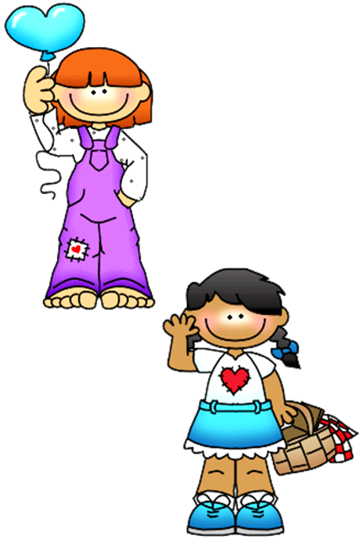


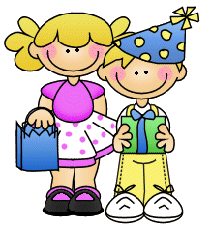
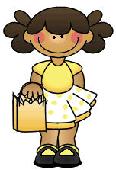




- Sue and Mehmet are seven years old.
_________________________
- Our teachers are helpful.
_________________________
- These books are very heavy.
I cannot carry these books.
_________________________
_________________________
- Şule’s dogs are very funny.
_________________________
- Murat is not at home. He went
to visit his grandparents.
_________________________
_________________________.

- Serkan is describing his family. Fill in the blanks according
to the given sentence.

Hello! ____ name is Serkan. ____ am seven years old. In ____ free
times I play football and go swimming. ____ go to primary school and
____ favourite lesson is music.I have got a brother and a sister.____
sister’s name is Vildan. ____ is ten years old. ____goes to primary school.
____ favourite lesson is English. ____ brother’s name is Hakan. ____ is
fifteen years old. ____goes to secondary school and ___ favourite lesson
is history.
____ father’s name is Kemal. ____ is 38 years old. ____ works as a
doctor. ____ loves ____ job very much. ____ patients also love ____ .
____ mother’s name is Melek. ____ is a nurse in the same hospital. ____
work together. ____ love ____ family and ____ are a happy family.
E) Choose the right answer.

- My /me mother is a nurse.
- This is my/mine my brother. His/her name is Tahsin.
- This is my/mine sister. His/her name is Vildan. I love his/her too much.
- Sibel bought a cat. Its/it’s name is Boo.
- I bought three books. I/her will read their/them quickly.
- I go to school with my/mine brother.
She/he is older than me/mine.
- We planted trees in my/our garden. their/they are very beautiful and
she/I love their/them too much.
- Did you see my/mine hat? I cannot find it/it’s .

F) Correct the mistakes and write the right pronouns.

- I prepare a Project about cats. He is very hard for me.
- Sibel is mine best friend. I have known him for seven years.
- Serkan is my best friend. He love
her too much.
- This is Ayşe. He is mine daughter.
- This can’t be yours bag. It is my.
- Miss Ayşe is me teacher. He teaches
English to ours.
- Mehmet is ours neighbour.
- Kerem is mine mother’s brother. So,
She is mine uncle.
G) Turn the underlined words into pronouns.

- Ahmet is my brother.
_________________________
- Kerem and Aslı are legendary
characters in our country.
_________________________
- This cat’s name is Paul.
_________________________
- My mother’s name is Sevgi.
_________________________
- Aslı is my little daughter.
_________________________

